SUBMITTED BY:  **Pacificador, Rhea Mae I. (202103123)**

YEAR AND SECTION: **BSIT-3A**

SUBMITTED TO:  **Mr. Johneros Puyo**

SUBJECT CODE:  **ITEC 101 (Human-Computer Interaction 2)**

**Submission Requirements:**

1. **LIVE PORTFOLIO LINK**

[**https://reeyahpacificode.github.io/MyWebPortfolio/**](https://reeyahpacificode.github.io/MyWebPortfolio/)

1. **GITHUB REPOSITORY LINKS**

[**https://github.com/reeyahPacifiCode/MyWebPortfolio.git**](https://github.com/reeyahPacifiCode/MyWebPortfolio.git)

* **CISCO Projects**

1. ACTIVITY 1 https://github.com/reeyahPacifiCode/cisco_actvity-1.git
2. ACTIVITY 2 <https://github.com/reeyahPacifiCode/ciscisco_actvity-2.git>
3. ACTIVITY 3 <https://github.com/reeyahPacifiCode/cisco_actvity-3.git>
4. ACTIVITY 4 <https://github.com/reeyahPacifiCode/cisco_activity-4.git>

* **C++ Projects**

1. ACTIVITY 1 <https://github.com/reeyahPacifiCode/clpus_activity-1.git>
2. ACTIVITY 2 <https://github.com/reeyahPacifiCode/cplus_activity-2.git>
3. ACTIVITY 3 <https://github.com/reeyahPacifiCode/cplus_activity-3.git>
4. ACTIVITY 4 <https://github.com/reeyahPacifiCode/cplus_activity-4.git>
5. ACTIVITY 5 <https://github.com/reeyahPacifiCode/cplus_activity-5.git>

* **JAVA Projects**

1. ACTIVITY 1 <https://github.com/reeyahPacifiCode/java_activity-1.git>
2. ACTIVITY 2 <https://github.com/reeyahPacifiCode/java_activity-2.git>
3. ACTIVITY 3 <https://github.com/reeyahPacifiCode/java_activity-3.git>
4. ACTIVITY 4 <https://github.com/reeyahPacifiCode/java_activity-4.git>
5. ACTIVITY 5 <https://github.com/reeyahPacifiCode/java_activity-5.git>
6. ACTIVITY 6 <https://github.com/reeyahPacifiCode/java_activity-6.git>
7. ACTIVITY 7 <https://github.com/reeyahPacifiCode/java_activity-7.git>
8. ACTIVITY 8 <https://github.com/reeyahPacifiCode/java_activity-8.git>

* **HTML and CSS Projects**

1. ACTIVITY 1 <https://github.com/reeyahPacifiCode/htmlcss_activity-1.git>
2. ACTIVITY 2 <https://github.com/reeyahPacifiCode/htmlcss_activity-2.git>
3. ACTIVITY 3 <https://github.com/reeyahPacifiCode/htmlcss_activity-3.git>
4. ACTIVITY 4 <https://github.com/reeyahPacifiCode/htmlcss_activity-4.git>
5. ACTIVITY 5 <https://github.com/reeyahPacifiCode/htmlcss_activity-5.git>
6. ACTIVITY 6 <https://github.com/reeyahPacifiCode/htmlcss_activity-6.git>

* **PHP Projects**

1. ACTIVITY 1 <https://github.com/reeyahPacifiCode/php_activity-1.git>
2. ACTIVITY 2 <https://github.com/reeyahPacifiCode/php_activity-2.git>
3. ACTIVITY 3 <https://github.com/reeyahPacifiCode/php_activity-3.git>

* **SCRATCH Projects**

1. ACTIVITY <https://github.com/reeyahPacifiCode/scratch_project.git>
2. **SCREENSHOTS OF PORTFOLIO PAGES**

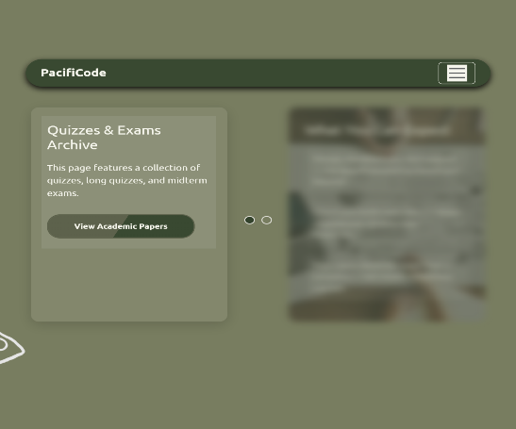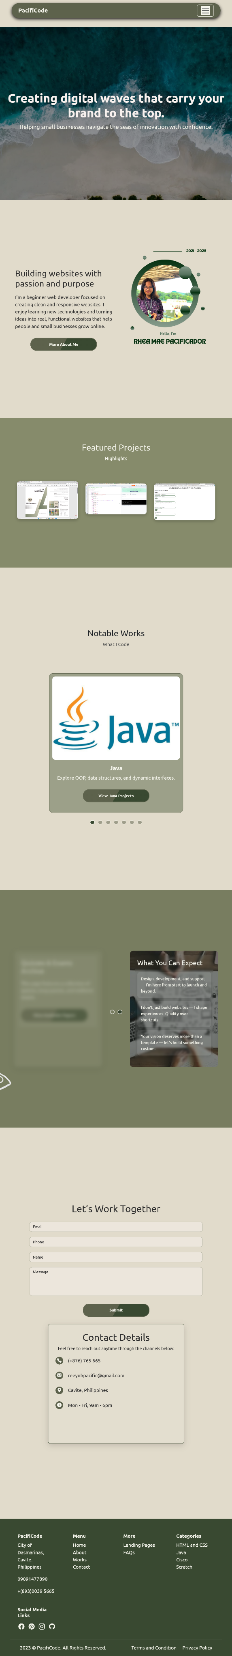

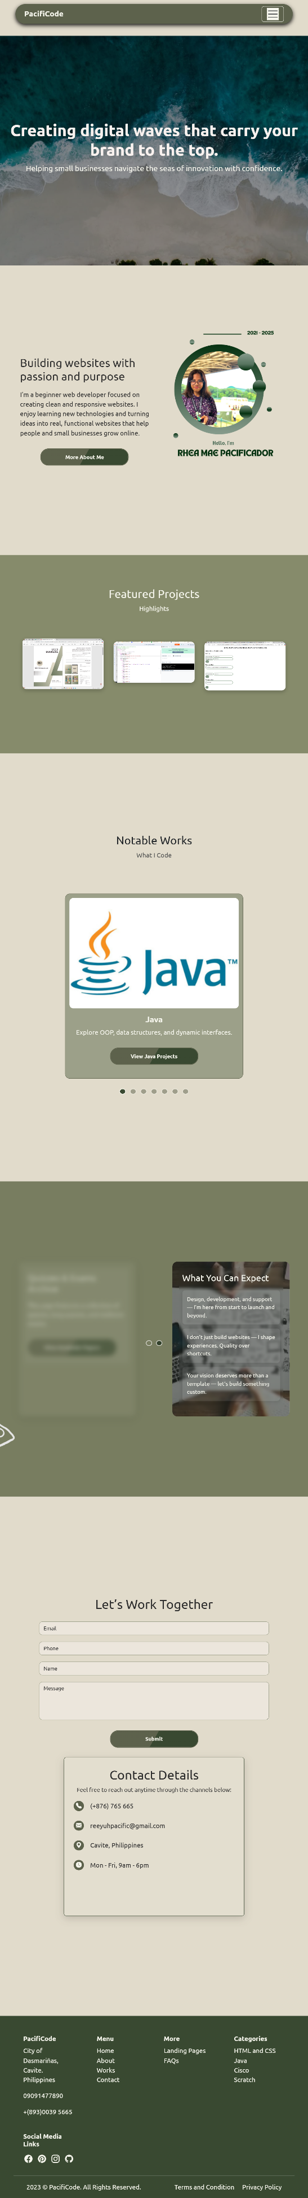

MAIN PAGE

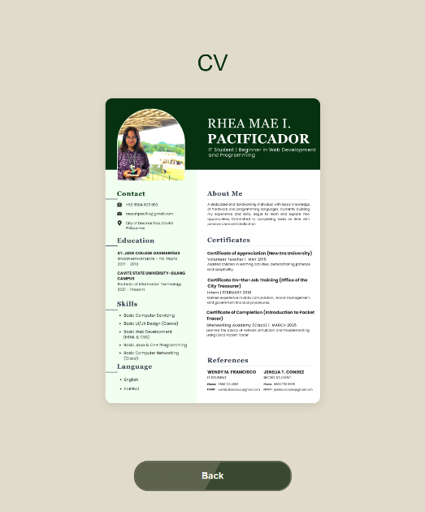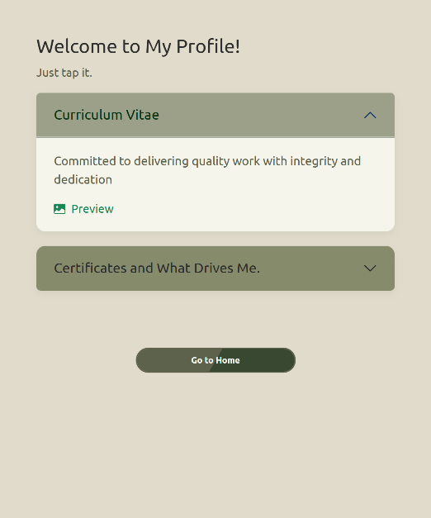

ABOUT PAGE

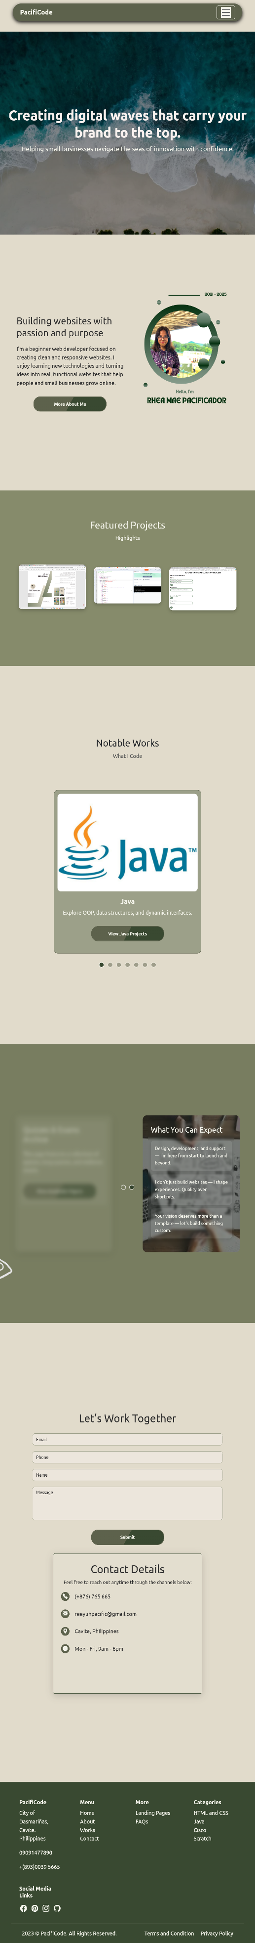

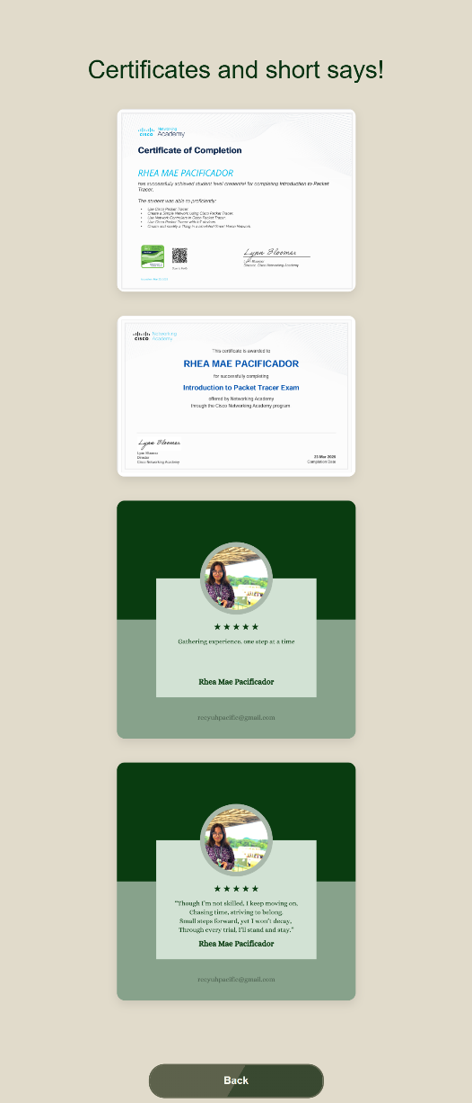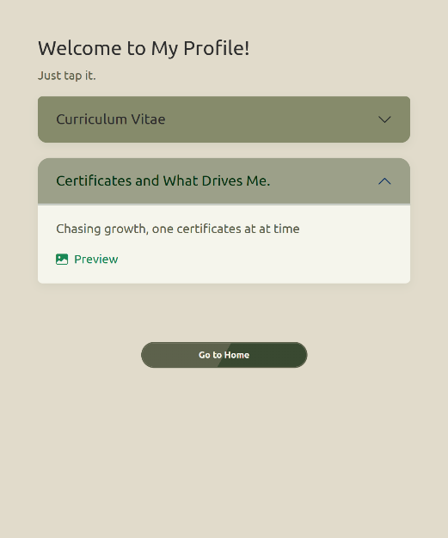

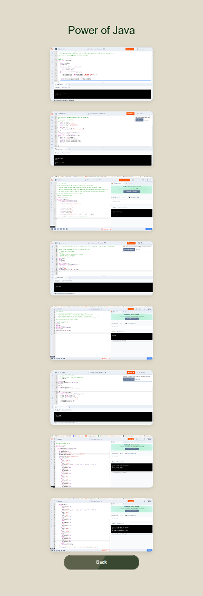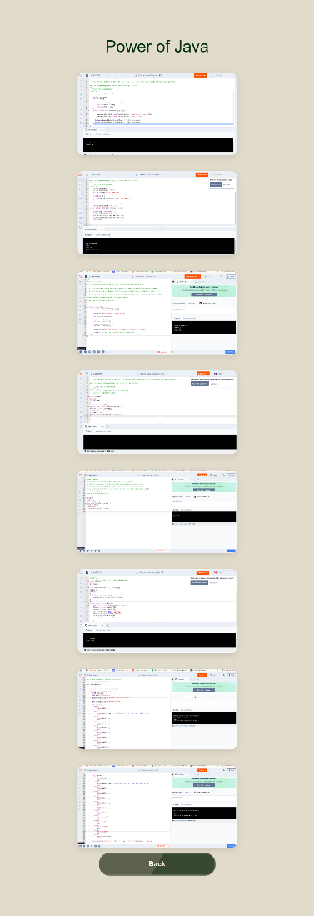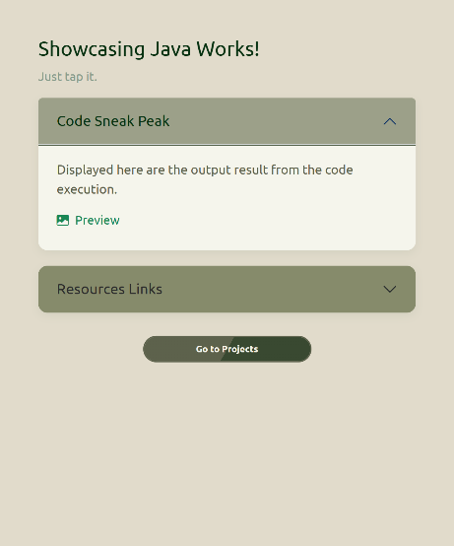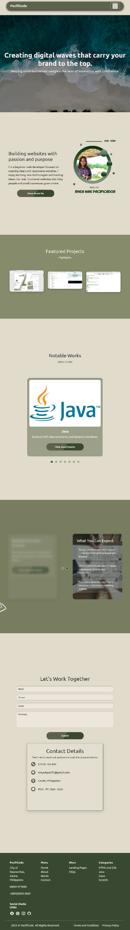

WORKS PAGE (Java)

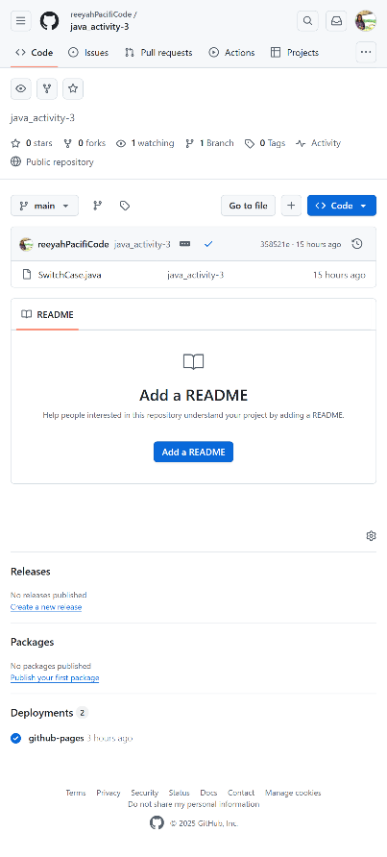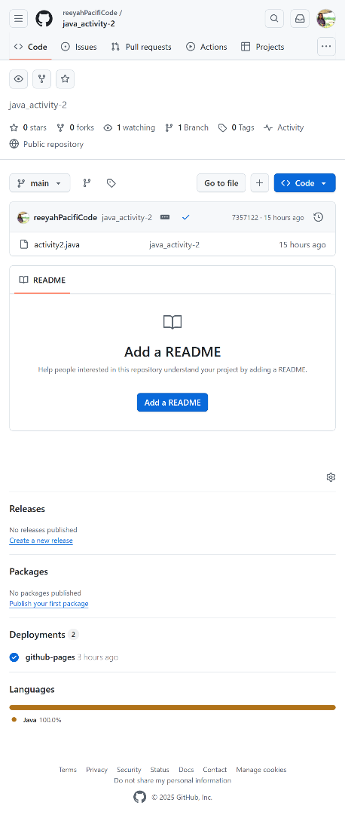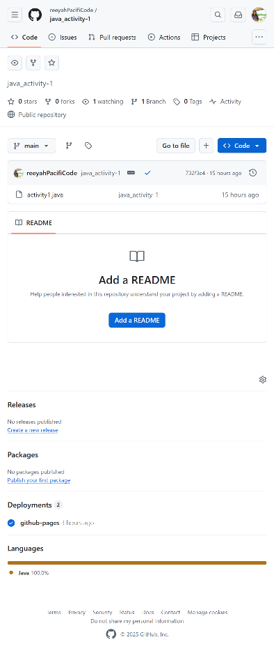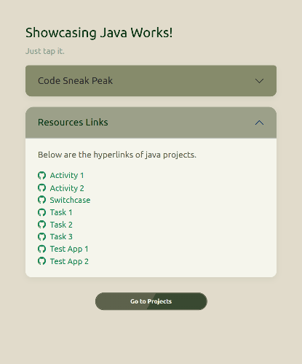

WORKS PAGE (C++)

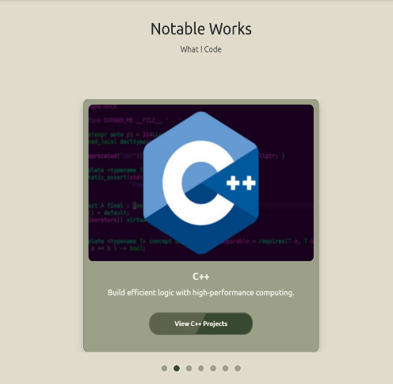

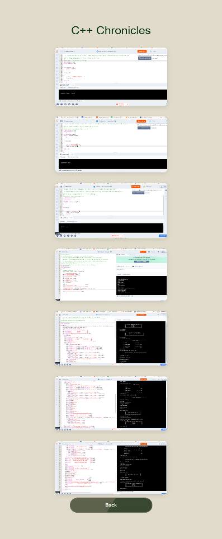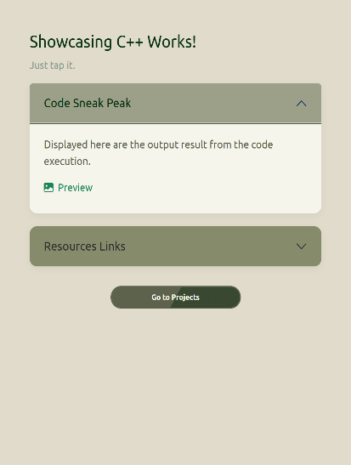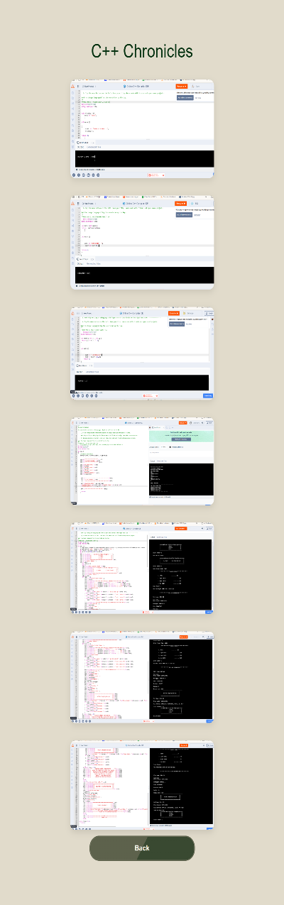

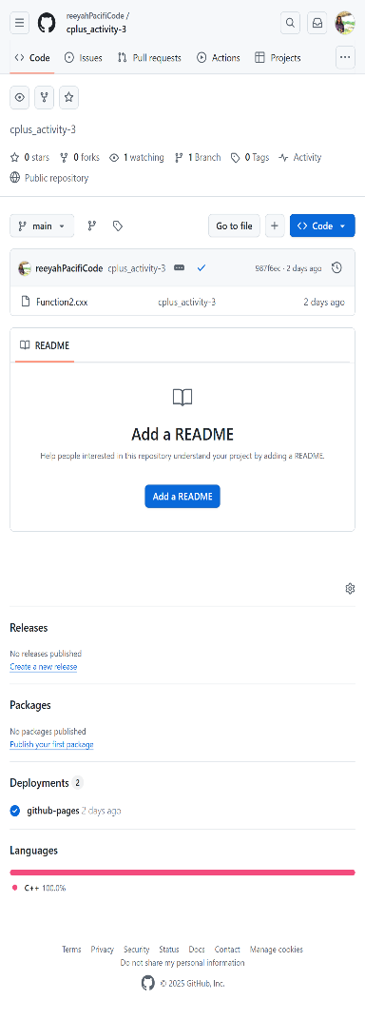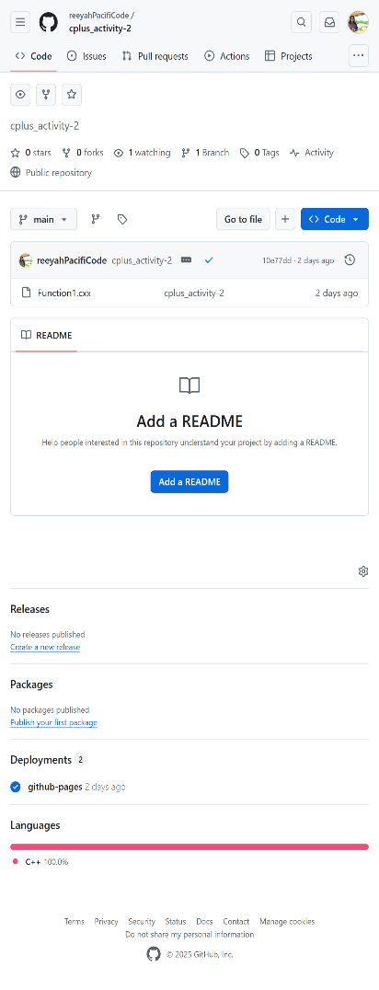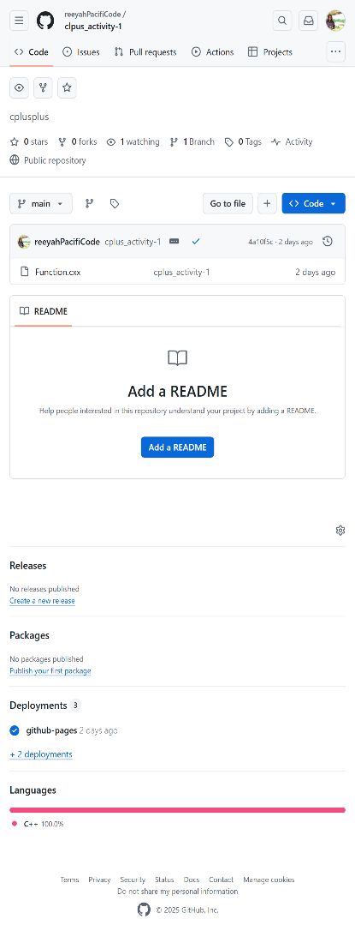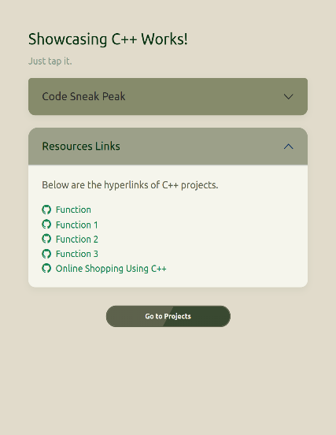

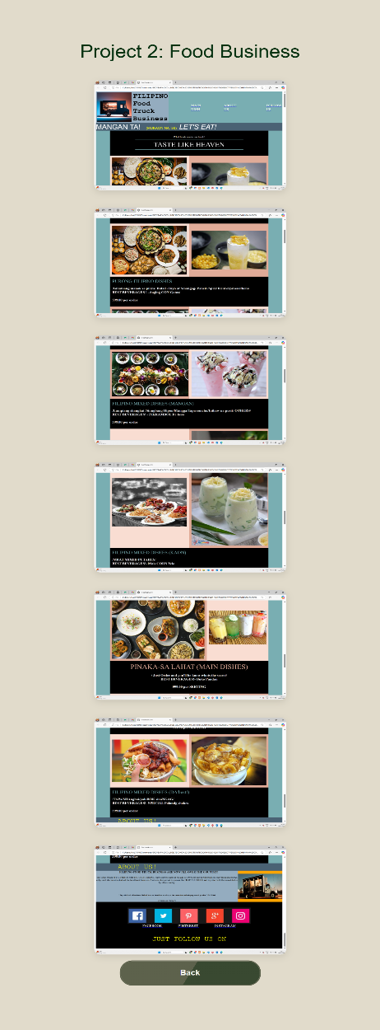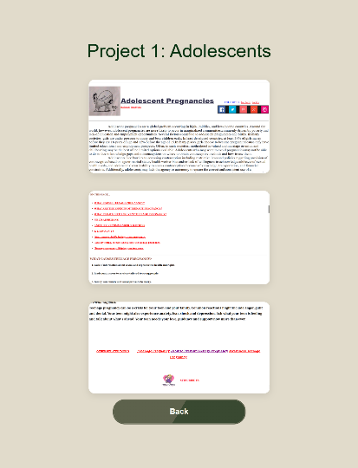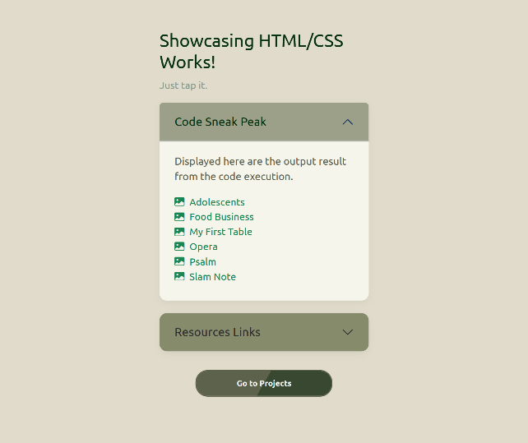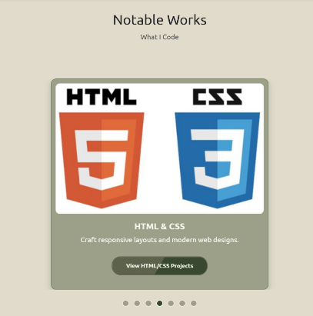

WORKS PAGE (HTML and CSS)

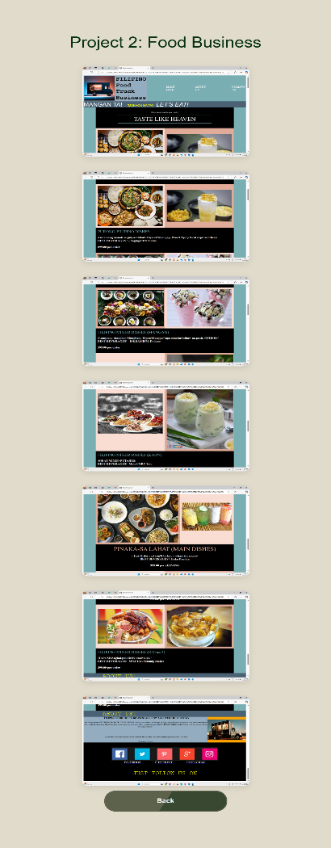

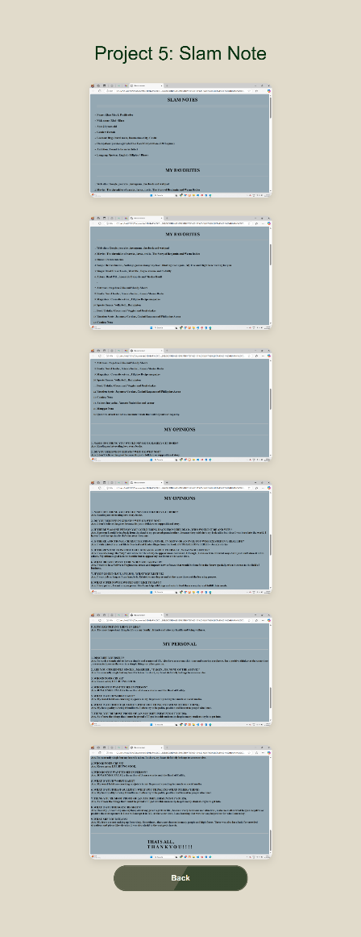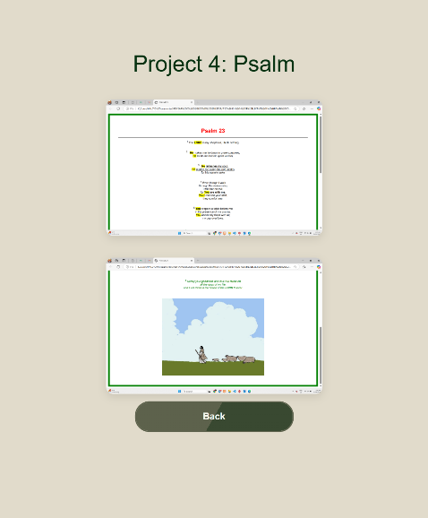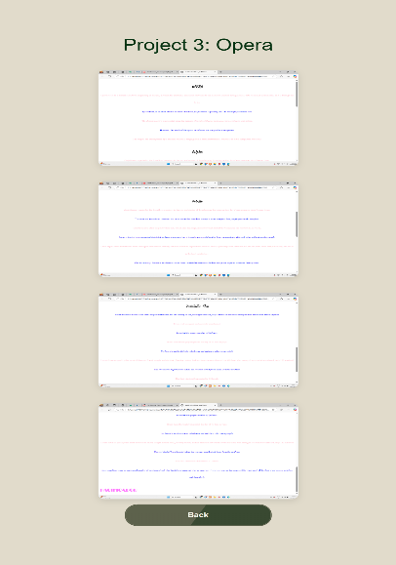

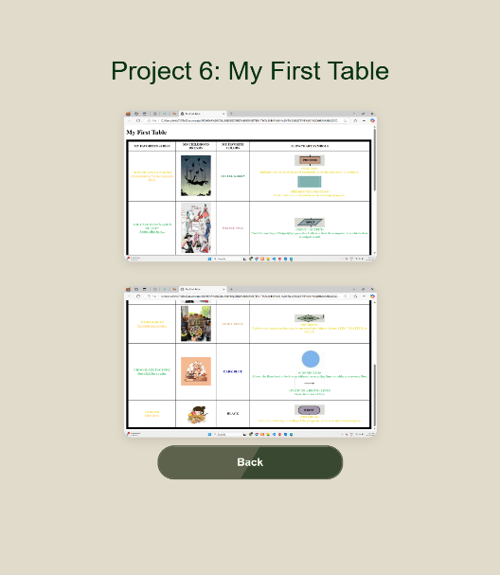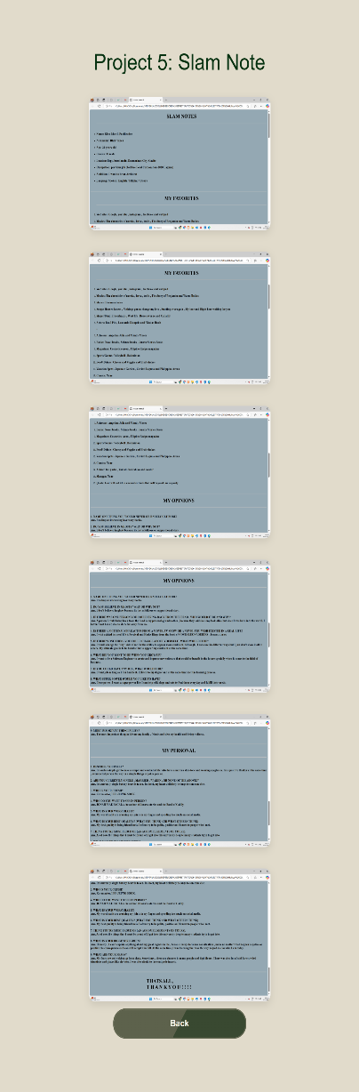

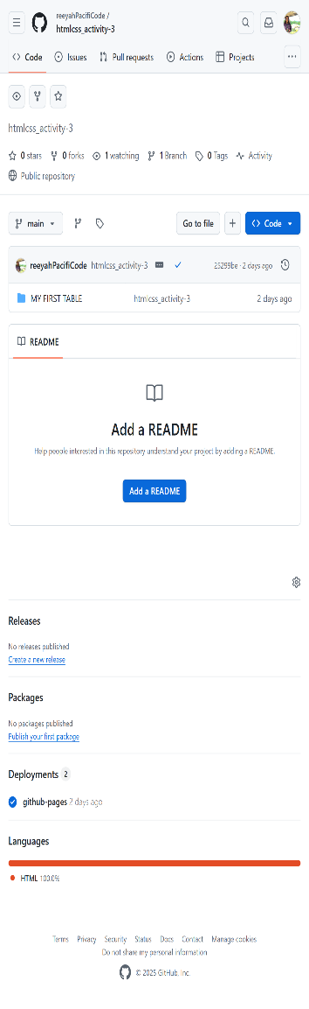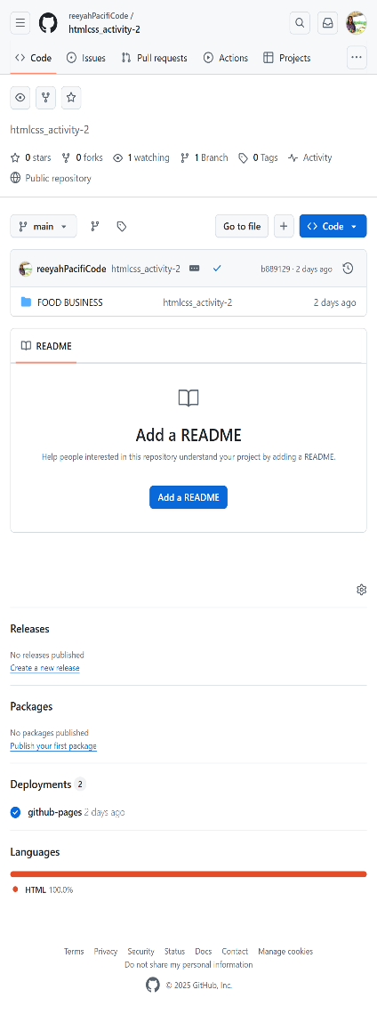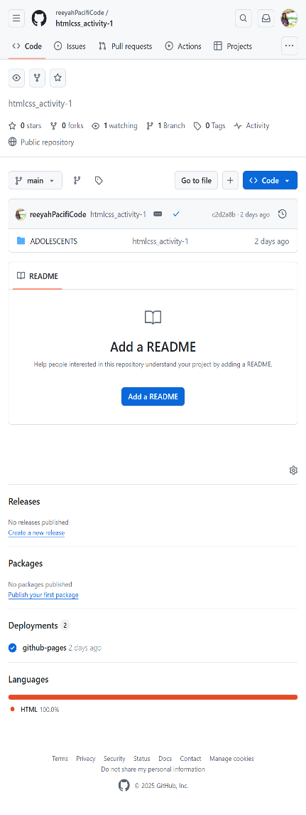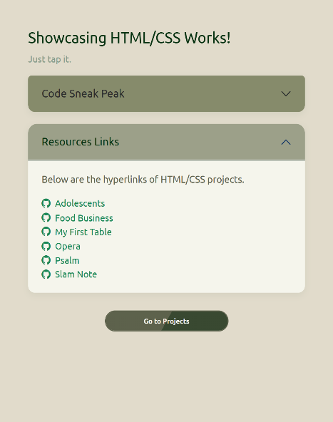

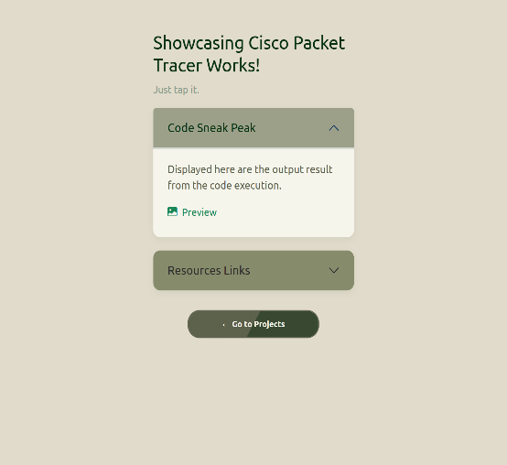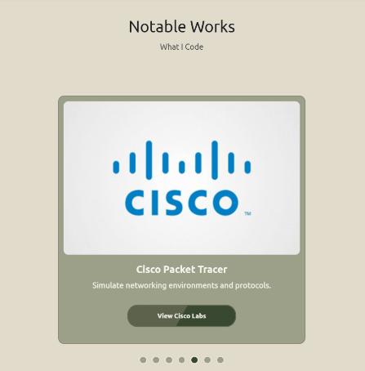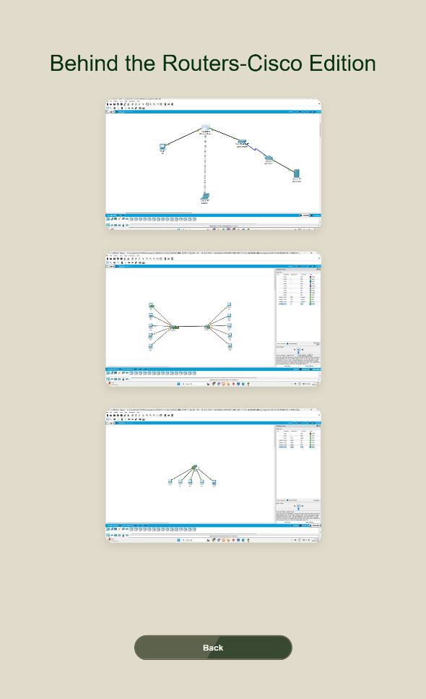

WORKS PAGE (Cisco)

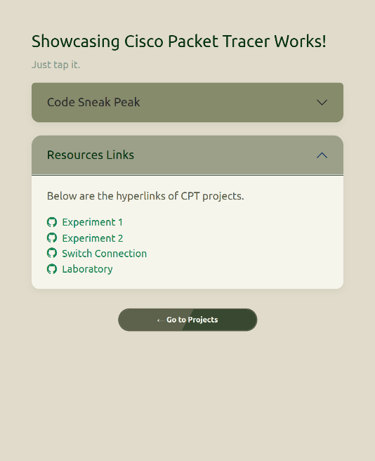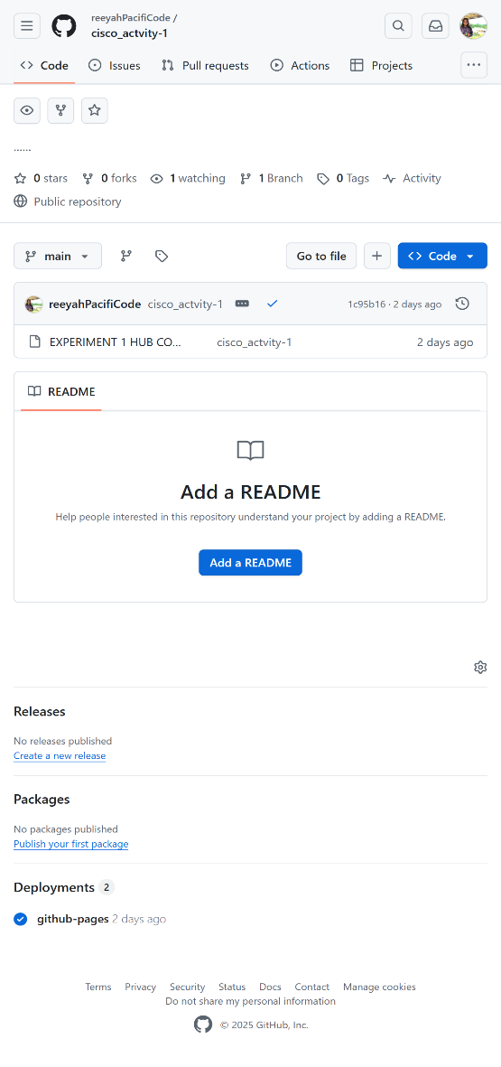

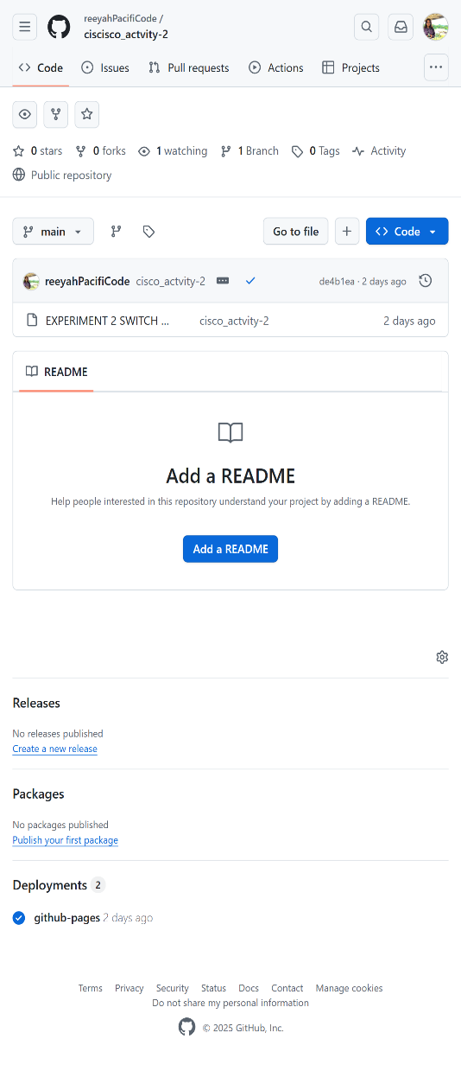

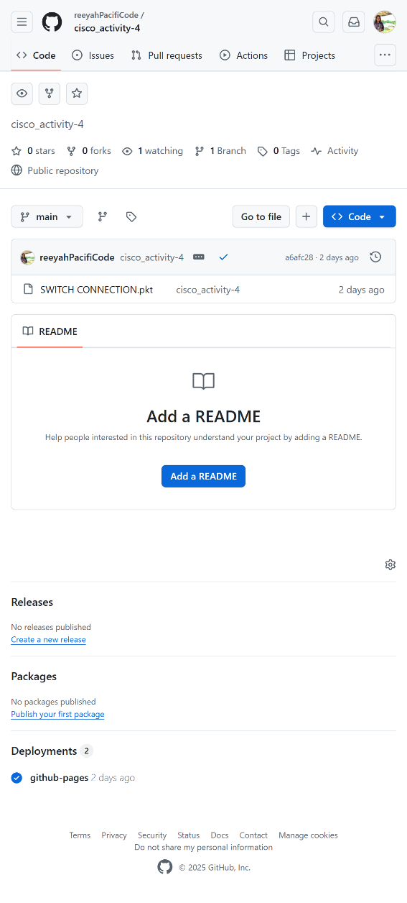

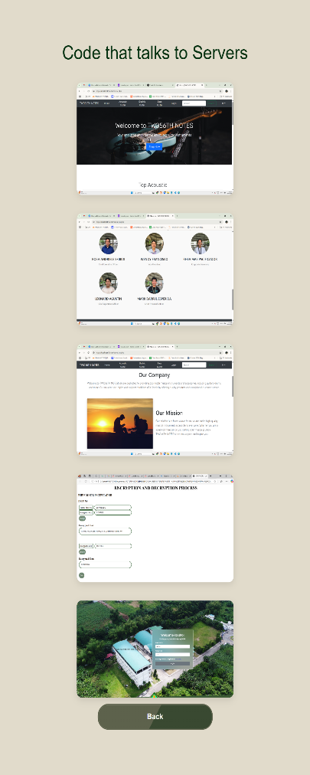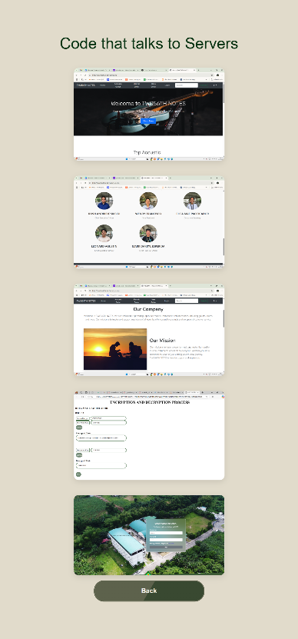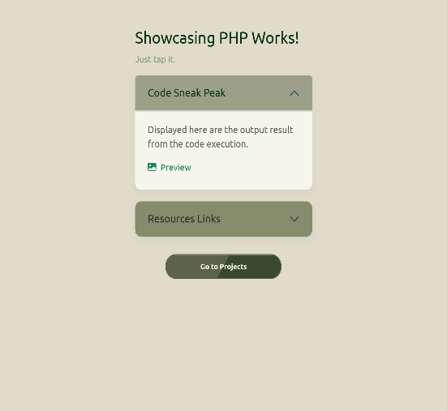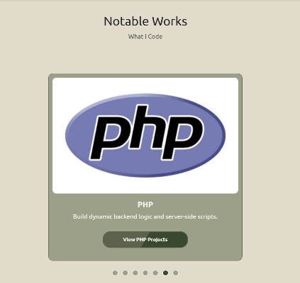

WORKS PAGE (Cisco)

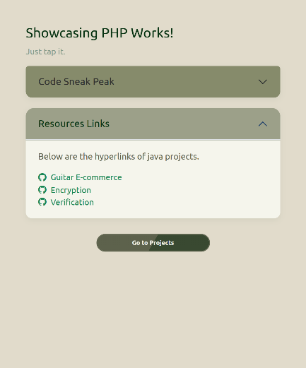

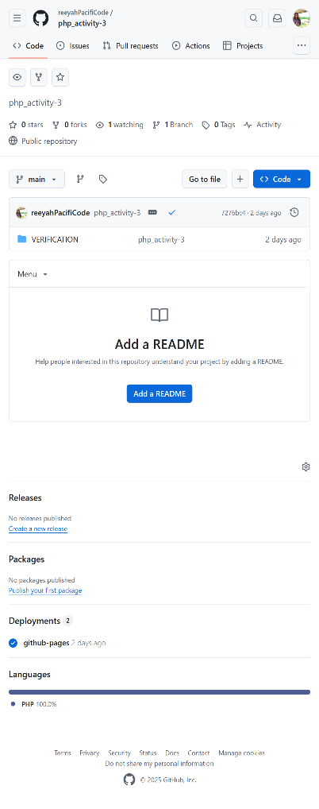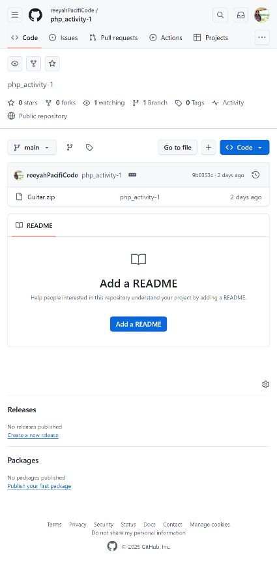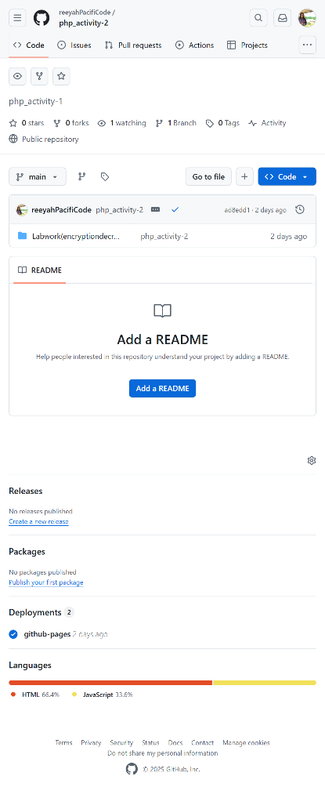

WORKS PAGE (UX/UI Design)

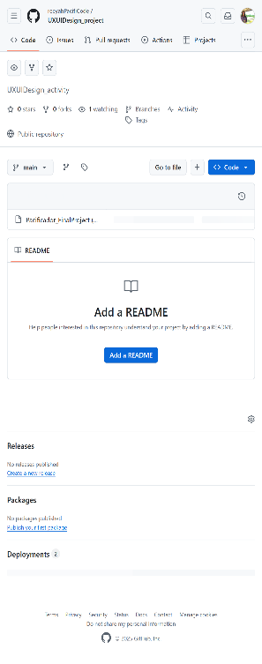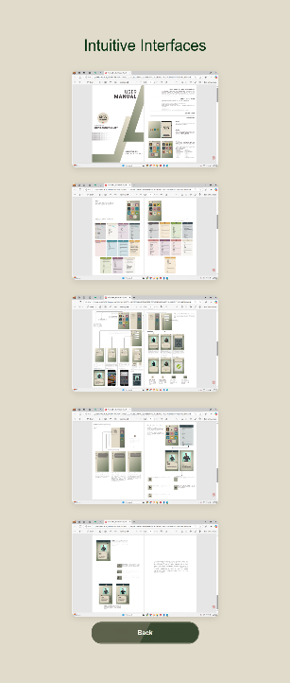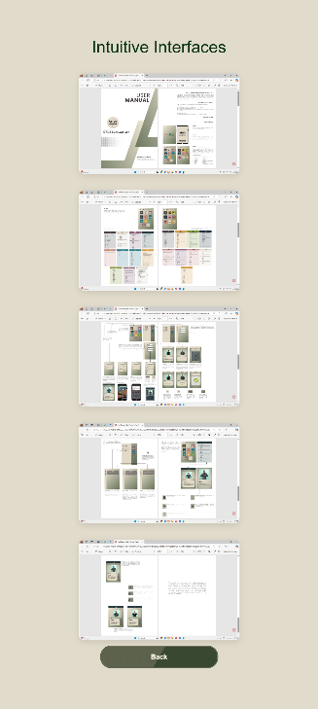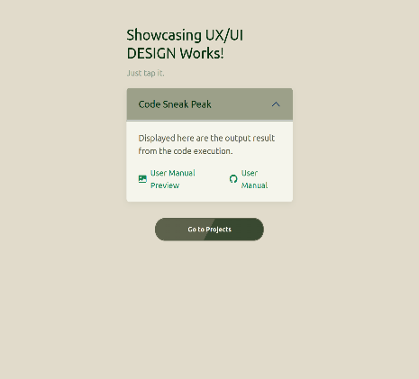****

WORKS PAGE (Scratch)

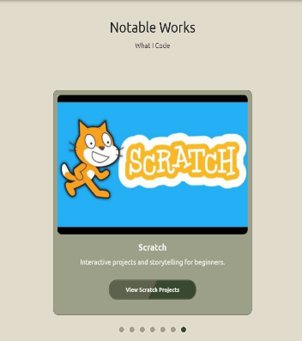

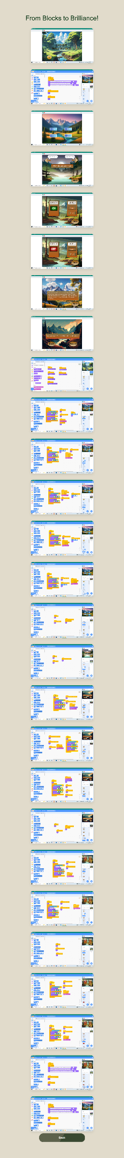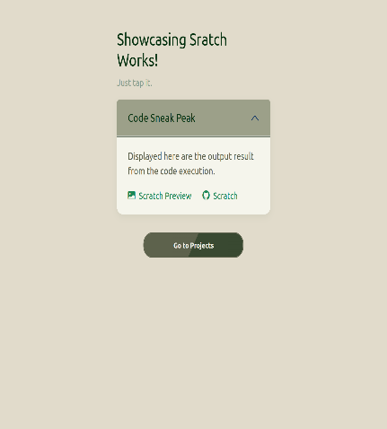

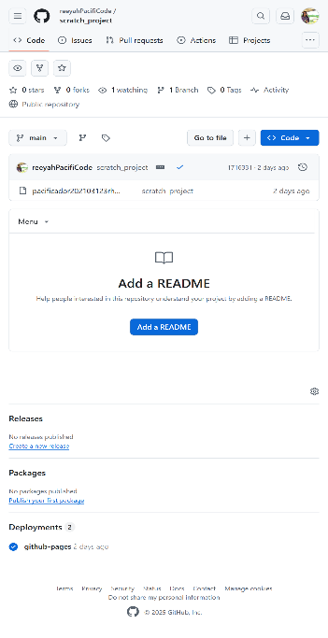

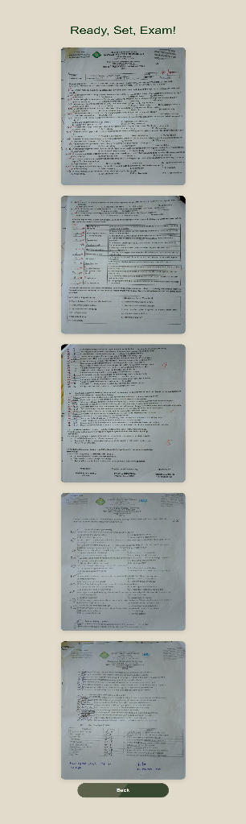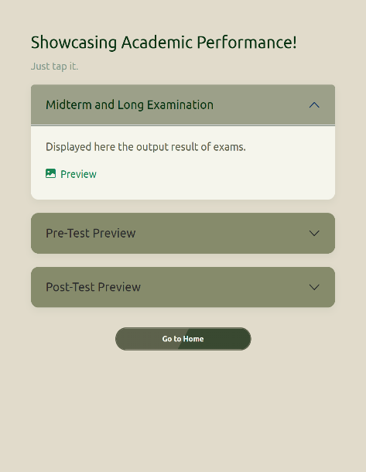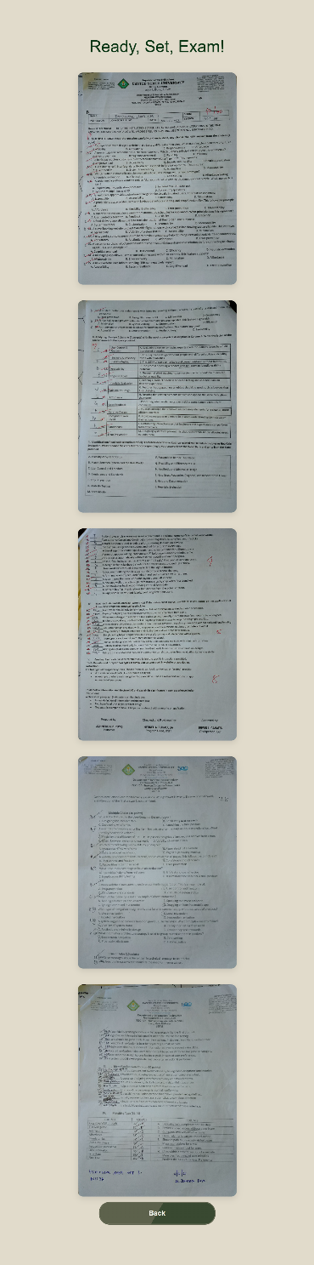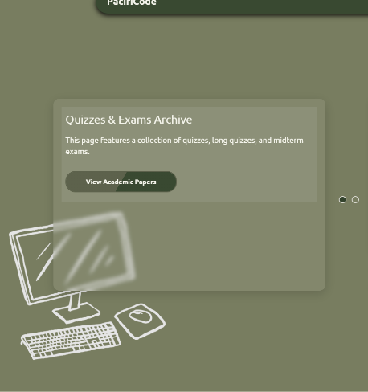

ASSESMENT PAGE

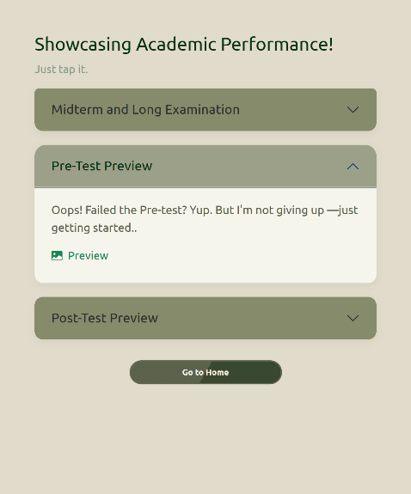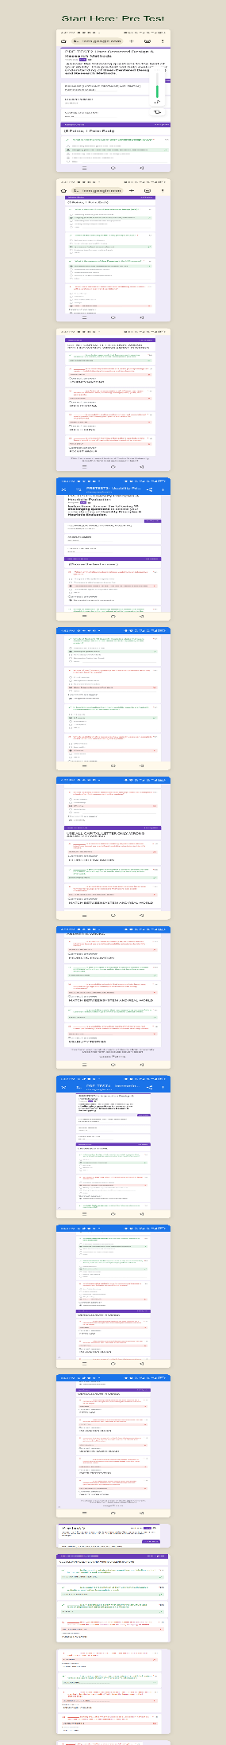

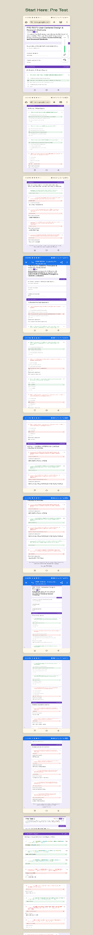

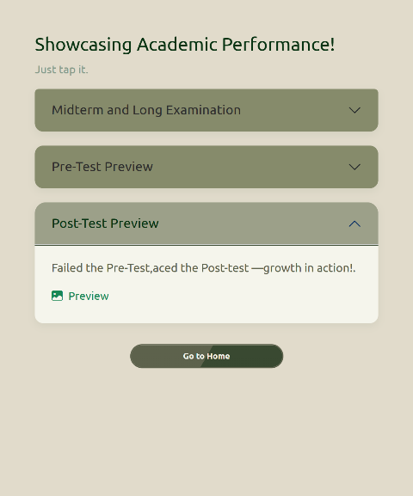

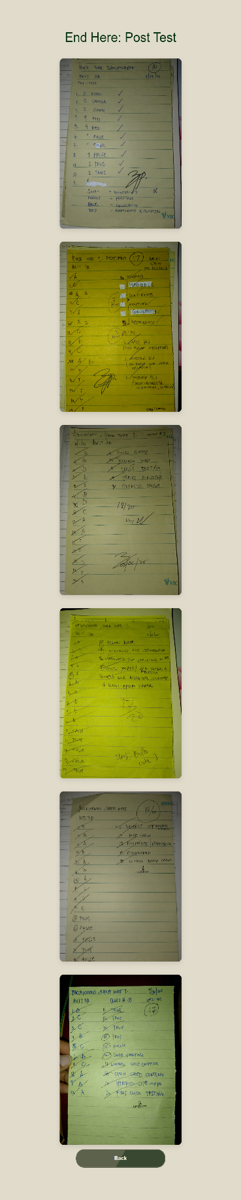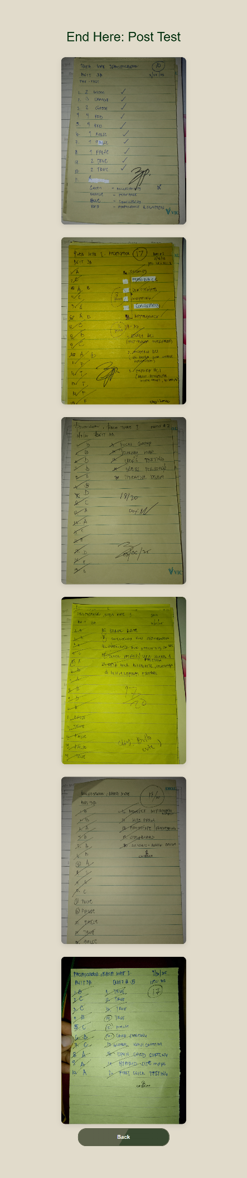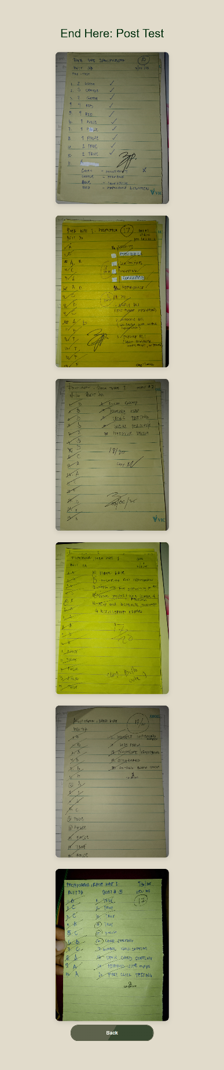



TERMS CONDITION AND PRIVACY POLICY PAGE

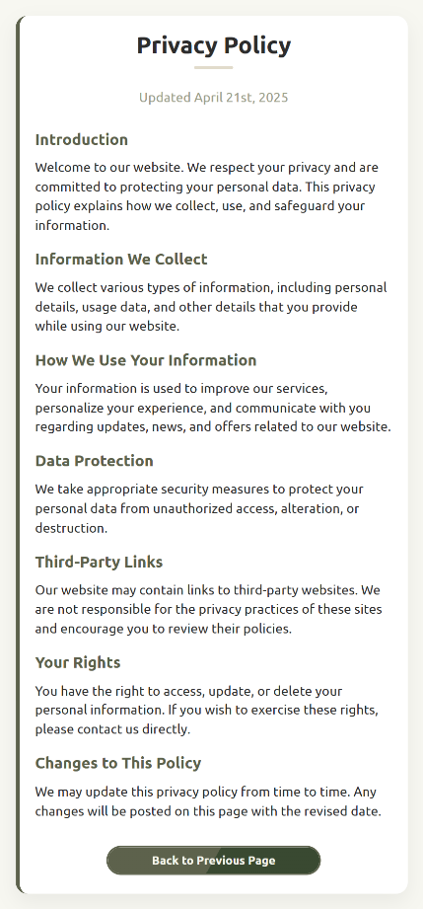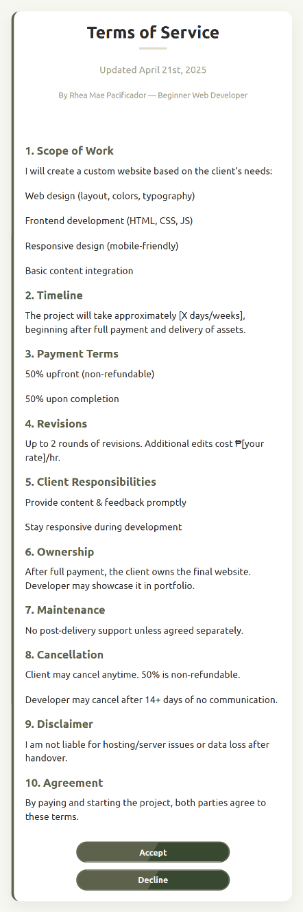

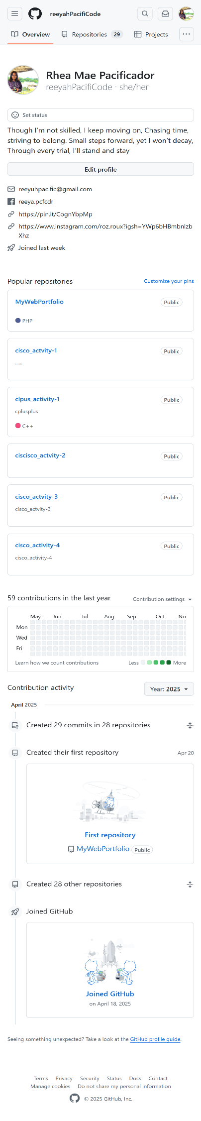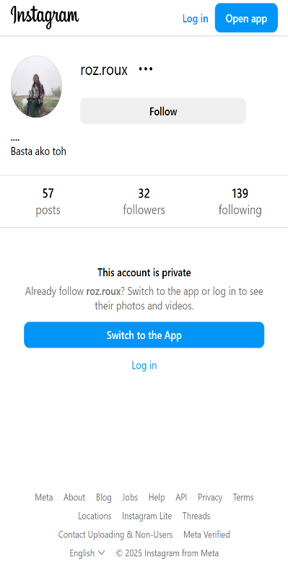

1. **SHORT REFLECTION**

As I reflect on this laboratory work, I am struck by how much it has changed my understanding of coding, layout design, and making a web portfolio mobile-responsive. I’ve learned a lot from this project—from structuring code, creating low-fidelity prototype designs, to thoughtfully considering the best aesthetic appeal for the theme, all while following the given criteria.

Looking back on the days I spent working on this portfolio—six straight days or even more—it was truly exhausting. I experienced insufficient sleep, moments of frustration, and became easily irritated due to continuous work. Through this experience, I realized that creating projects like this requires a long period of time. It’s important to go through the process moderately and not rush to finish everything in a short span. For the sake of one’s well-being, it is essential to get enough sleep, drink water regularly, and eat nutritious meals. This kind of work demands both physical and mental energy. Without balance, there’s a risk of getting sick, which can negatively affect the outcome of the project.

Diving into the process, I started by creating a low-fidelity prototype in my notebook with a simple design. Then, I structured it in VS Code using the basic HTML anatomy. It became clear to me how important comments are in coding—they help separate sections and serve as notes for what each part is intended to do. I added comments to my code to document my plans and guide my structure. I first set up the sections and containers for each feature I wanted to include. I was amazed to discover the different purposes of various tags and attributes. I learned about unique IDs, classes, and elements, including self-closing tags that don't require an end tag. Furthermore, I learned that with the anchor (<a>) tag, if you want to link to a specific section of a page, you can add # followed by the ID of that section. This allows you to navigate directly to the preferred section, even if it’s on another page. I also came to understand the concept of specificity, not only in CSS but also in JavaScript. There's a proper arrangement and flow in how code is loaded and executed. Each language—HTML, CSS, and JavaScript—has its own structure and rules. For example, in JavaScript, statements are often enclosed in curly brackets to logically execute functions or conditions. I also learned about using clean and organized path directories in anchor tags when linking to other pages. It involves the use of dots (.) and slashes (/). The more slashes you use, the deeper it goes into subfolders—each slash representing a step from one folder to another.

One more thing I enjoyed is using abbreviations in VS Code. I love how it provides IntelliSense, which can detect what I’m trying to type and suggest it automatically. This feature makes coding much faster and more efficient. When it comes to designing, I learned that file extensions must always be present and correct. This part of the process excites me the most—choosing color themes, positioning elements in the layout, working with columns, grids, flexbox, and applying box-sizing while keeping in mind the rules of the CSS box model. I enjoy using shorthand properties in CSS because they make coding much faster. However, I still struggle with padding and margin, especially when it comes to responsiveness. I really enjoy using transitions and animations—they make websites more fun and interactive.

I also explored Bootstrap, where I learned that it follows standard sizing through classes. The x-axis and y-axis are used for horizontal and vertical alignment, respectively. The units often used are rem and vh, and I discovered the importance of z-index and the !important rule. The z-index assigns stacking order and gives elements priority in the design. I learned a lot about media queries and their breakpoints. I often used the browser’s inspect tool to check mobile responsiveness. But honestly, mobile responsiveness was the most challenging part for me. It was quite frustrating and confusing at times, especially when the layout wouldn't turn out the way I wanted even after several tries. It really gave me a headache—but I learned a lot from the process. The final part of this learning journey that truly amazed me was uploading my project to GitHub. I used to think GitHub was weird—I always heard people talk about it, but I had no idea how to use it. Thanks to this subject and activity, I’ve learned so much about how it works.

During this process, I created my GitHub account and wrote a short bio for my profile. It was fun customizing my profile and making it feel more personal. With the help of the instructions, I successfully uploaded my web portfolio to GitHub using Git. I discovered that there are several ways to push the project—through Git Bash, Command Prompt, or directly from the VS Code terminal. I chose to use the terminal in VS Code and followed the steps carefully. At one point, I encountered a warning—not an error, just a reminder that my files were being added to Git and that line endings were being converted from LF to CRLF, I'm right to pronounce it? haha. I also enjoyed using git add and git commit commands. They help document the changes made in the code, which are reflected in GitHub profile. And then—voilà! My project was uploaded to my GitHub repository pages. It was a bit challenging when I had to upload the project with a slow internet connection. That played a big role in the delays and failed attempts to upload. I also encountered SSH and HTTPS. I learned that when files are over 100MB, using SSH is often recommended (correct me if I’m wrong, haha). Eventually, the project went live. It took a while to upload and generate the live site link—maybe because of my slow internet.

And finally, when I want to update the project from VS Code, I just use the git push command again, and the changes reflect on GitHub easily. Overall, it was truly a mix of emotions—there were moments of frustration, disappointments to myself and pressure, but more than anything, I enjoyed the experience and learned so much from it. This time, I can genuinely feel a growing desire to pursue the world of web development. If given the chance, I want to gain more experience and continue improving my skills. What I created may not compare to what my classmates have accomplished—they’re incredibly talented—but I’m still thankful. I was able to bring my own ideas and layout to life through my web portfolio, and that in itself is something I’m proud of. I learned a lot, and I truly enjoyed this activity. And Sir, Thank you for this kind of activity and experience!

1. **SKETCH OR WIREFRAME**

